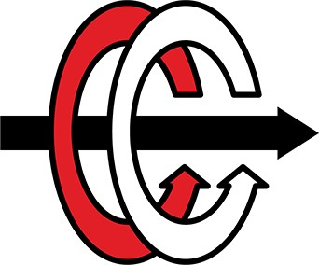

# MIDDLE EAST TECHNICAL UNIVERSITY DEPARTMENT OF ELECTRICAL & ELECTRONICS ENGINEERING

**EE 463 - Static Power Conversion I - Term Project Deadly Viper Assassination Squad Inc.**

**Development of a AC-DC Battery Charger for Rooftop Wind Turbine Applications**

**Mehmet KILIÇ - 2232262 Ali BELLİ - 2231421 Mustafa YILDIZ - 2233013**

**Table of Contents**

**Introduction 3**

**Problem Definition 4**

**Topology Selection 5**

**Simulation Results 9**

**Component Selection 12**

**Conclusion 16**

**Appendix 17**

1. **Introduction**

Deadly Viper Assassination Squad Incorporation (D.V.A.S. Inc.) is established to provide practical solutions to the problems in the power electronics area. The main application areas in the power electronics field are AC to DC rectifiers and DC to DC converters.

In recent years, effects of climate change have started to show themselves at various locations of the world. Although we are at the beginning of the expected huge climate shift, we are already experiencing unusual meteorological events. In order to delay the effects of climate change, governments and companies have started to invest on renewable energy sources. Therefore, the share of renewables in the energy production industry is getting larger every year.

In addition to the conventional bulk power plants, distributed energy resources (DER), which is a new concept that appeared with the advancements in the renewables area, are being used in order to decrease the carbon emissions of the end user. Instead of large power plants in MW scale, the number of small power generation units located in the distribution level is increasing.

In this project, D.V.A.S. inc. proposes a solution for the interface between a small wind turbine located at the top of the EEE department of the METU and it’s battery. First stage of the proposed solution includes AC to DC conversion of the wind turbine output whose frequency and amplitude varies randomly. Then, rectified variable-DC voltage is regulated to provide charging operation for the battery.

Project will be completed in two steps. This report includes the conceptual design discussion, simulation results and CAD model of the proposed solution. After submitting this report and getting feedback, we will continue to develop our solution according to the feedback taken and submit the final report. Before discussing the solution procedure, it would be wise to define the problem and project requirements. Then, potential solution approaches will be discussed and the proposed solution will be presented.

1. **Problem Definition**

The main problem that yields us to work on this project is that the road next to the park of the EEE department needs to be illuminated continuously even in the nights. This action requires a large energy supply which is not available in that condition. For this reason, a small wind turbine is placed at the top of the roof. However, the speed and strength of the wind is not constant. Therefore, converted electrical energy must be stored in order to use at the evening hours for illumination. For storage, a battery is used at the output of the wind turbine. Proposed AC-DC charger design will convert variable AC to constant DC. Since the terminal voltage of the electrochemical battery would change with its state of charge, the charger must supply constant current DC independent of the terminal voltage of the battery. This definition intuitively shapes our design.

The system specifications for this project is defined as below.

* Open circuit voltage peak: 330 𝑉𝑙𝑖𝑛𝑒−𝑡𝑜−𝑙𝑖𝑛𝑒
* Battery capacity: 13 Ah
* Battery nominal voltage: 24 V
* Output current: 2 A
* Output current ripple: %20 of average current
* Inertia: 0.00027 kg.m^2
* Viscous Damping: 0.005024 N.m.s
* Poles: 2
* Voltage Constant: 110 𝑉𝑝𝑒𝑎𝑘𝑙−𝑙/𝑘𝑟𝑝𝑚
* Stator Resistance: 10.58 Ohm
* Armature Inductance: 16.7 mH

While conducting this project we followed the following problem solution steps;

➔ System topology selection

➔ Rectifier design and simulation

➔ Buck converter design and simulation

➔ Analog controller design that fixes the output current to the given specifications

➔ At the end of each step we choose proper components according to the simulation results.

## Topology Selection

In preceding chapter, problem definition is made and the conceptual requirements are determined without entering the technical design discussion. In this step, possible topologies which satisfy the requirements defined above will be discussed and selected topology will be represented. According to the problem definition, we have determined that below topologies are suitable for this application;

* + Three Phase Full Bridge Thyristor Rectifier
  + Three Phase Full Bridge Diode Rectifier + Buck Converter (x2)
  + Three Phase Full Bridge Diode Rectifier + Buck Converter

Using a three phase full bridge Thyristor rectifier would be beneficial in order to decrease the size and number of the components. However, in this case we have to control 6 gates at the same time. This would increase the cost because we need to feed 6 gate signals at the same time which requires 3 phase control drivers. Also, controlling 6 gates at the same time would increase the complexity of the controller and decrease the reliability of the system. For that reasons, a Thyristor rectifier is not preferred.

After eliminating the Thyristor rectifier, the team focused on the diode rectifier + buck converter topology. The given source in the project is a three phase generator which means that we need to select a three phase rectifier type. At this stage, three phase half wave/full wave diode rectifier topologies are considered. According to the output current specification, we need to feed the system with a high voltage so that we can reach 2A at the buck converter output. Therefore, a three phase full bridge diode rectifier is determined as the best option for this application thanks to its larger voltage output.

Since the output voltage of the rectifier is large, whether a single buck converter would be capable of converting it for the battery or not is discussed. Note that the controller must operate at higher frequencies in order to convert such a high voltage to the 24V 2A DC. After conducting a short market research, it is found that there are plenty of analog controller ICs

that can operate in such conditions. Therefore, a single stage buck converter is preferred in order to decrease the cost, number of components and volume of the design.

After determining the number of buck converter stages, control strategy is discussed. Batteries can be charged in constant voltage, constant current or constant current-constant voltage modes of operation. Since the terminal voltage of the battery varies depending on its state of charge, the constant current charging method is adopted due to its simplicity. In the design, output current will be kept constant by an analog controller IC. Details of the controller will be discussed in detail later.

A typical buck converter topology circuit diagram is as below;

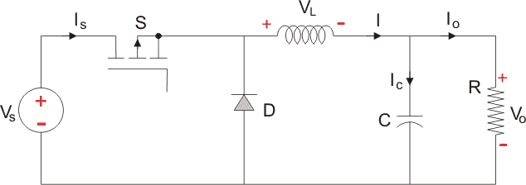

*Figure 1.1.General buck converter topology*

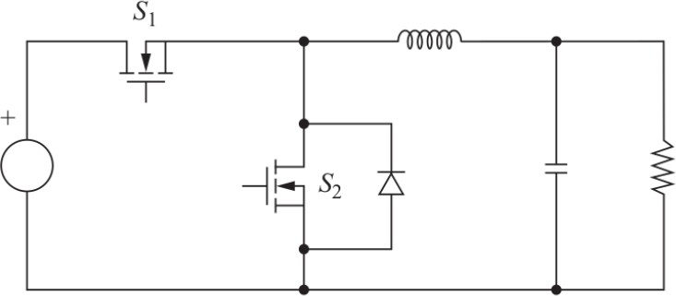In order to increase the efficiency by decreasing the diode losses, diode D is changed with a mosfet, and this configuration is known as synchronous buck converter. The synchronous buck converter circuit diagram is shown as below;

*Figure 1.2.Synchronous buck converter topology*

Figure 2 show the theoretical controller block.

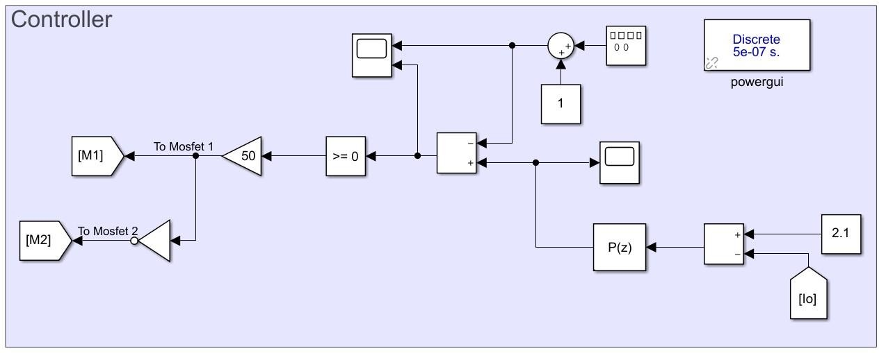

*Figure 2. Controller Block*

Controller is designed with two outputs. Theoretically designed controller takes output current as a measurement and compares it with reference current. Then passes it through a P controller. Amplified P controller output is compared with a constant frequency sawtooth waveform. If the difference between the amplified error and sawtooth is less or equal than zero, M1 is on and M2 is off. The system is worked based on this process, and at the end stabilizes the output current level to the allowed range of [1.8V, 2.2V]. Since we inserted Mosfet 2 instead of diode in the buck converter circuit, we are eliminating the diode loss and increasing the system efficiency.

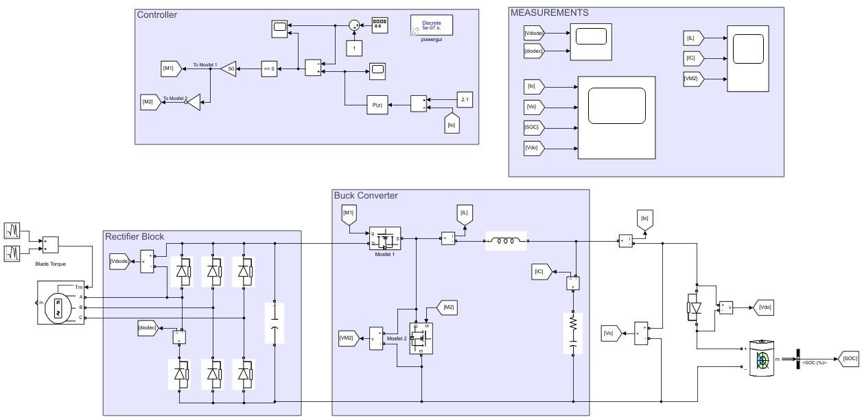

*Figure 2.Complete simulation model*

## Simulation Results

In this part of the report simulation results are represented. First, diode rectifier simulations are presented. The rectifier topology configuration is as shown in figure 4.

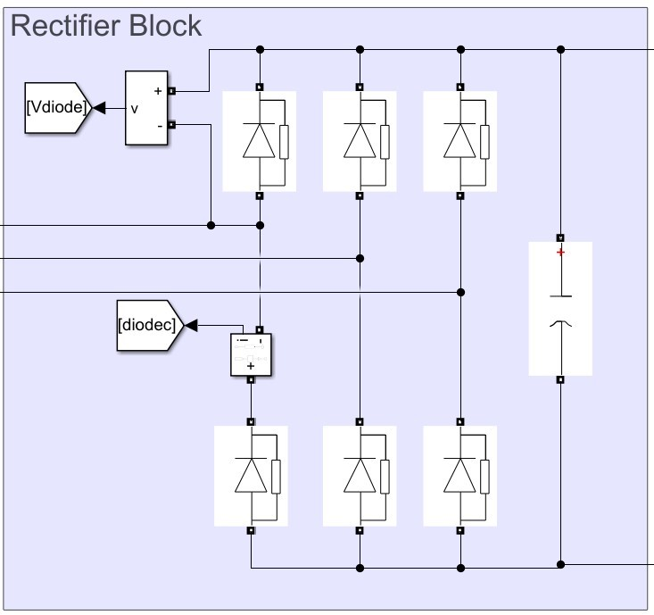

*Figure 3.Three phase diode rectifier topology*

One of the critical parts in this step is selection of the capacitor size. It decreases the output voltage ripple significantly. Since there is no specification about the rectifier output ripple, complete elimination of the ripple voltage was not the aim. Instead, an easy to find capacitor is tried and the result was satisfying so a 470 microfarad capacitor will be used in the design. Both the dimensions of the capacitor and the ripple value is suitable. Figure 5 shows the simulation result with C=470 microfarad.

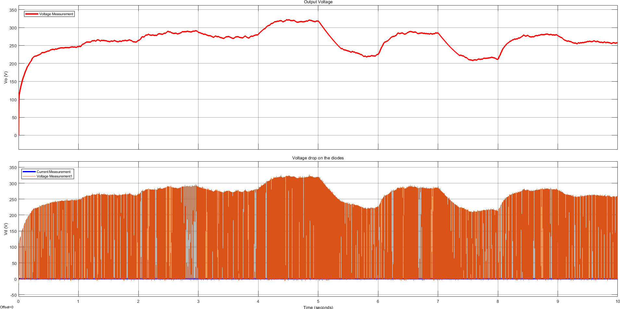

*Figure 4.Rectifier output voltage waveform 470 microfarad capacitor inserted*

Increasing the capacitor value could decrease the ripple value. However, since the controller of the buck converter would adjust the output voltage automatically, dimensions of the capacitor becomes the most important parameter. Since the selected capacitor provides enough filtering with relatively small volume, there is no need for larger capacitors.

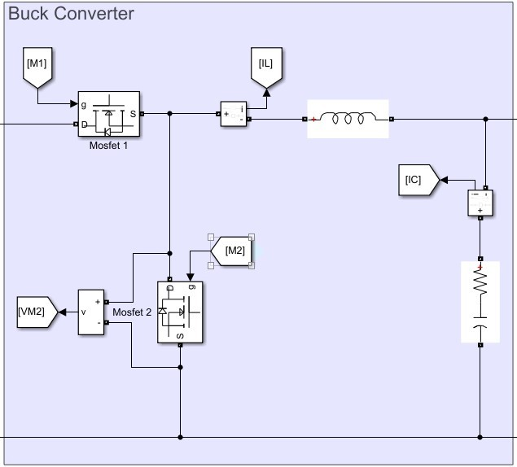

*Figure 5. Synchronous Buck Converter*

The inductor and capacitor values were evaluated according to the following equations;

𝑉𝑖𝑛 − 𝑉𝑜𝑢𝑡

𝐿𝑚𝑖𝑛 = 𝑉𝑜𝑢𝑡. 𝛥𝐼 . 𝑓 . 𝑉 (1)

𝐿 𝑠 𝑖𝑛

𝛥𝐼𝐿

𝐶𝑜𝑢𝑡,𝑚𝑖𝑛 = 8. 𝑓 . 𝛥𝑉

(2)

𝑠 𝑜𝑢𝑡

After inserting circuit parameters to the equation (1), 𝐿𝑚𝑖𝑛 can be found as below;

𝐿𝑚𝑖𝑛

24𝑥(300 − 24)

=

0.4𝑥200000𝑥300

= 2.74𝑥10−4𝐻

After inserting circuit parameters to the equation (2), 𝐶𝑜𝑢𝑡 can be found as below;

𝐶𝑜𝑢𝑡

0.4

=

8𝑥200000𝑥0.5

= 0.5𝑥10−6 𝐹

These values are the minimum ones. For the sake of the reliability, the parameters were chosen larger than these minimum values which are presented in the above. For the buck converter, 1.5 microfarad capacitor and 1 milihenry inductor were used in order to obtain the required results.

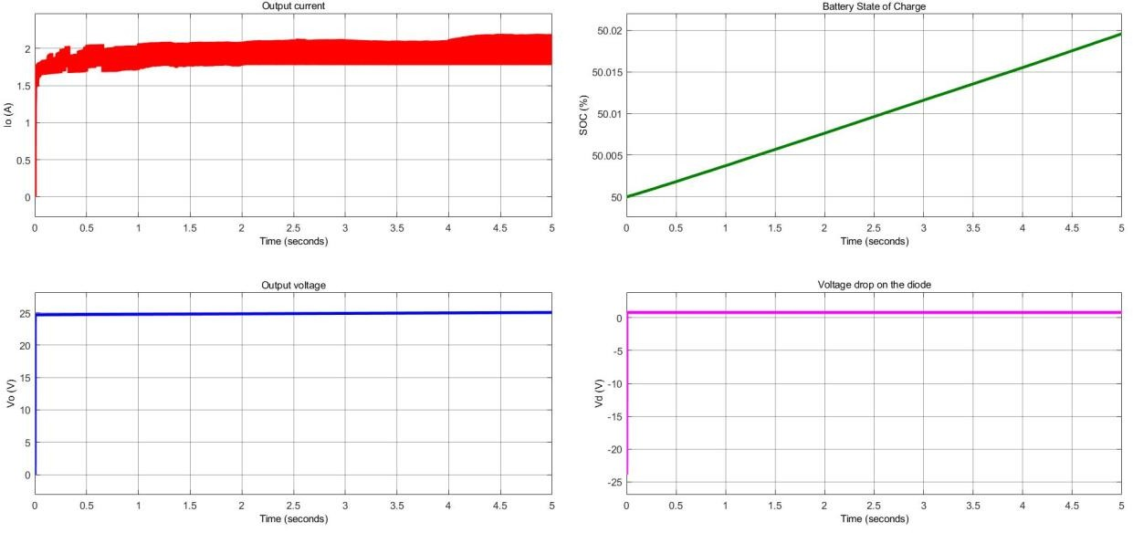In order to understand the above configuration working, we need to analyze it with the controller.

*Figure 6.Output Current Measurements of Buck Converter*

As can be seen from the above figure, the output current waveform is within the %20 percent ripple current in the 2A specification. Output voltage is constant at 24V because the state of charge is almost constant. Note that supplying 2A for 10 seconds cannot charge the battery significantly. In addition to the buck converter, a series diode is added at the output because at the beginning the smoothing capacitor of the buck converter is empty. If that battery is charged, it would discharge on the capacitor. In order to avoid this reverse current flow, a series diode is added at the output. Figure 7 also verifies that this measure is meaningful because the voltage on the diode at t=0 is negative, which means that if the capacitor wouldn't be used, the battery would discharge into the capacitor.

## Component Selection

In this part of the report, the component selections are presented. The followed roadmap for the component selection is measuring the related voltages and currents for the analyzed component. According to the extreme points the related components are selected. In this report the selections starting from the rectifier stage to the end stage are presented orderly.

In the rectifier stage there are two components; diodes and capacitor. The voltage and current measurements for the rectifier diodes were given in figure 8 as below.

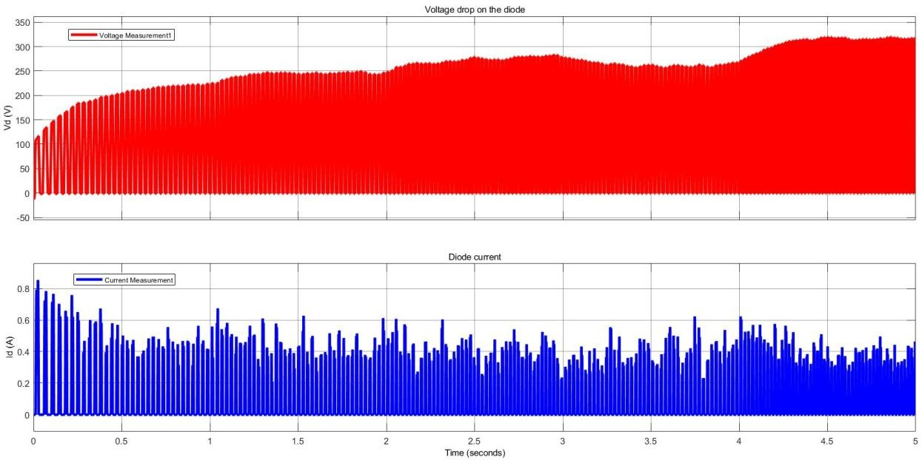

*Figure 7.Rectifier diode characteristics*

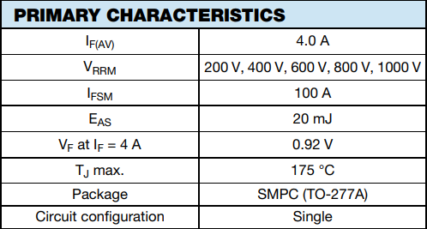For the safety of the design, components need to be selected with 1.5 multiples of the measurements. The voltage over diodes will be measured as approximately 325V, and the currents as maximum 0.9A. Then according to the extreme points selected diode is presented in figure 9.

*Figure 8. AS4PJ-M3/86A Diode Primary Characteristics*

The table shows 5 subtypes of the diode. The selection for this application is the middle one whose part number is included in the figure name. The maximum repetitive reverse voltage that this diode can carry is 600V and forward current is 4A. These ratings are much higher than this system’s rectifier diodes ratings shown in figure 8.

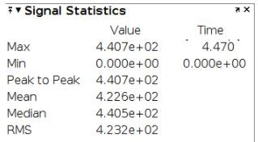Capacitors will be selected according to the voltage over it. It sees output voltage, and rectifier output voltage characteristics are shown in figure 10.

*Figure 9. Rectifier output voltage characteristics*

The capacitor is faced with at most 441V peak. Therefore, the capacitor needs to be selected accordingly its rated voltage which should be larger than 441V. Since these types of circuit components are dangerous for the health of the circuit board, these selections should be made at least 1.5 multiples of the capacitor maximum voltage level in order to prevent it from exploding. The selected capacitor is “ALS70A471DB500 KEMET”. It’s maximum rated voltage is 600V which is enough for this project. The figure for this capacitor is shown in figure 11.

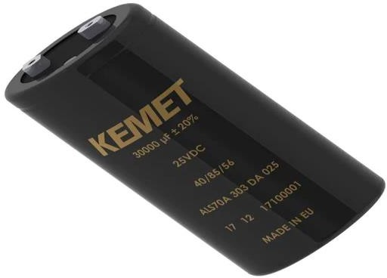

*Figure 10. ALS70A471DB500 Rectifier Output Capacitor*

With those selections the rectifier side is completed. For the converter side switching element (MOSFET), inductor and capacitor should be selected. The following figure 12 shows the inductor current, capacitor current and 2nd Mosfet ratings.

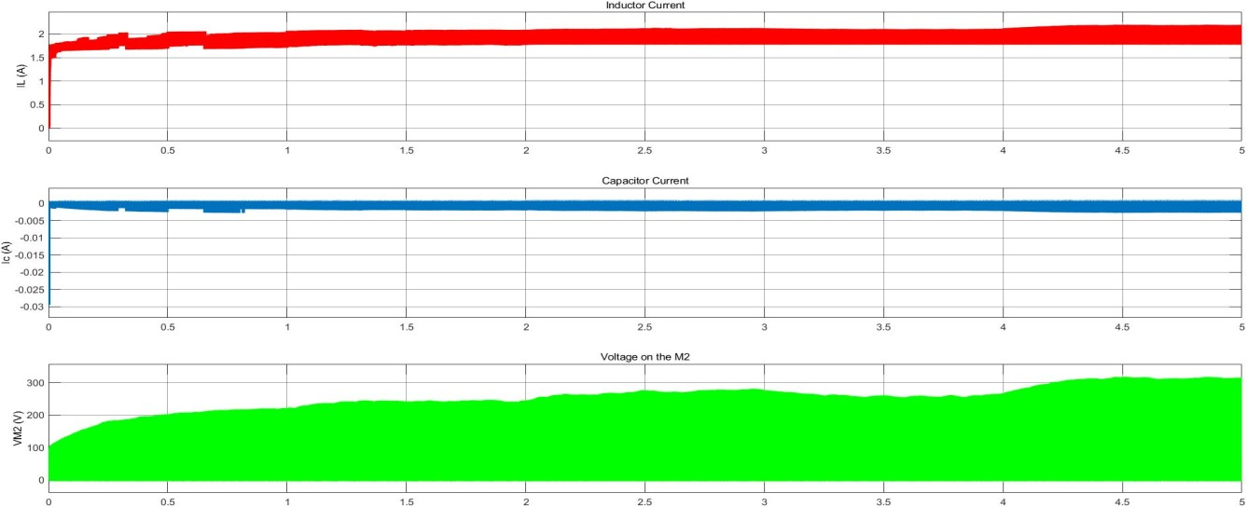

*Figure 11. Converter components waveforms*

As can be seen above figure inductor current reaches to approximately 2 amperes. Therefore, an inductor should be selected such that it can carry that much current over it. Accordingly, the PM2120-102K-RC inductor which is capable of carrying 2.5Amperes current should be selected. The size of the inductor was determined according to the output current ripples. For this scenario, 1mH inductor is enough to filter ripples up to the limited regions. The selected inductor is shown in figure 13.

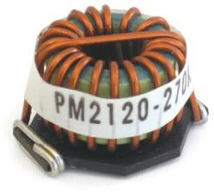

*Figure 12. Buck converter PM2120-102K-RC inductance selection.*

On the converter side switching elements need to be selected. For this application, mosfet as a switching element is selected due to its capability of carrying 300-350V applications and speed related advantages. As can be seen on figure 12, mosfet 2 is faced with 300-350V voltage over it. Therefore, FQD6N50C-D mosfet is selected. It can bear 500 volts over it, so it can be used in the circuit safely.

Last component that needs to be chosen based on figure 12 is the buck converter output capacitor. Since the battery is connected to the output, the capacitor is faced with 24V nominal battery voltage. The capacitor should be selected according to this criterion. Since this application does not require higher rated voltages ceramic capacitors will be enough for this type of application. The selected capacitor is 885012207087. It has 1.5 microfarad capacitance, and is capable of 50V voltage. These properties are enough for this type of application.

When the mosfet 1 is off, there will be no current that charges the capacitor. However, at that time the capacitor is charged from the battery. This will decrease the system efficiency. In order to prevent this action, a diode in the direction of the positive battery terminal can be placed. After inserting this diode, the battery will not feed the buck converter capacitor. Diode will prevent this action, and system efficiency also the battery charge oscillations is improved. For this operation 3A, 45V diode will be enough because this diode will face with

approximately 2 amperes current and 24 volts’ voltage. Therefore, TSSW3U45 diode were selected.

As discussed above, the system is controlled by feeding the mosfet gate terminals. Therefore, an integrated circuit gate driver is required in order to complete the controller action. Since Mosfets are faced with approximately 350 Volts voltages over them, a 500-600 Volts IC driver is capable of the requirements of this application. Therefore, the integrated circuit driver FAD7191M1X can satisfy the system requirements.

1. **Conclusion**

In this report, the development process of an AC-DC battery charger is represented. First, the problem is defined and requirements are determined. Since the power supply is a wind turbine, frequency and amplitude of the generated electricity varies randomly. Therefore, the designed product should be capable of converting variable frequency and variable amplitude AC to constant current DC with determined specifications of the project. According to the problem definition and requirements, conceptual design is completed. Without diving into deep technical discussions, capabilities that product must have are determined. After the conceptual design stage, technical discussions are conducted and topology selection is made. In this stage, different topologies are compared and the best option is determined. Designed topology is simulated with ideal components and the operation conditions that the real components must be capable to work under are determined. According to the determined values, real components are found from the market. Then, the full simulation with real components is done and a PCB schematic is drawn. At the end of this report, the design process is completed.

After submitting this report, designed topology will be revised according to the feedback taken.